FORMULATING ANTIMICROBIAL DENTAL CEMENT -LEACHING STUDIES OF ZINC PHOSPHATE, MODIFIED GLASS IONOMER CEMENT IN WATER AND SALIVA
Sunitha Medasani
Email: sunitha.akella25@gmail.com
Address: Nightingale Valley Practice, BS4 4HU, Bristol
Abstract:
This study presents a comprehensive investigation into the properties and behavior of Zinc Phosphate (ZnPO₄) and modified Glass ionomer dental cement, a promising material for dental and biomaterial applications. The cement was synthesized by blending ZnO powder and phosphoric acid, followed by shaping into discs and curing. These discs were subjected to immersion in deionized water and artificial saliva over a month, and pH changes and ion release were monitored. Our findings reveal distinct interactions between ZnPO₄ cement and different environments, reflected in varying pH levels and ion release patterns. The results underscore the importance of the cement's composition in influencing its behavior and ion leaching characteristics. While providing insights into short-term interactions, the study also highlights avenues for future research. The exploration of extended immersion periods could offer insights into long-term stability, while investigations into compositional variations could elucidate optimal ratios for desired properties. Further studies are recommended to assess mechanical strength, biocompatibility, and clinical applications of ZnPO₄ cement. Comparative analyses with existing dental cements could provide a valuable benchmark. By optimizing curing conditions and compositions, enhanced versions of ZnPO₄ cement could be developed for specific applications. Ultimately, this research contributes to the fundamental understanding of ZnPO₄ cement behavior, guiding the path toward potential advancements in dental and biomaterial sciences, with implications for medical implant and dental restoration technologies.

INTRODUCTION:
Dental cements have long played an essential role in dental practices, facilitating tasks such as affixing dental restorations, sealing gaps, and stabilizing orthodontic appliances (Ishikawa, 2003). However, the susceptibility of these materials to microbial colonization poses an ongoing concern (B Haller, 1998). This research sets its focus on the formulation of antimicrobial dental cement, targeting the development of materials that can actively impede the proliferation of microorganisms within the oral milieu (Zana D. Lila-Krasniqi, 2022).
Leaching studies constitute a pivotal aspect of this research endeavor, enabling an in-depth comprehension of how dental cements interact with their surroundings (C.H, 2012) (S.B, 2008). These materials are subjected to leaching studies in both water and saliva, providing insights into their leaching patterns, the release of active components, and the potential antimicrobial efficacy in an environment that closely mimics the oral cavity.
Zinc phosphate, well-established dental cement known for its durability and strength, is being explored for its potential antimicrobial attributes (Kispélyi, 2017) (Hamdy, 2018). Zinc phosphate cement's antimicrobial potential could be attributed to the release of zinc ions, which have known antibacterial properties. This property makes zinc phosphate cement valuable for minimizing bacterial growth at restoration interfaces and in clinical situations where bacterial control is essential.
The significance of formulating zinc phosphate and modified glass ionomer cement (GIC) for antimicrobial action is evident from their demonstrated effectiveness against bacteria associated with caries. Zinc oxide-eugenol cement, which contains zinc phosphate, was observed to have considerable antimicrobial activity. Additionally, the modified GIC containing chlorhexidine displayed enhanced antibacterial effects against specific organisms relevant to deep caries.
Formulating antimicrobial dental cement involves incorporating certain additives or agents that have demonstrated antimicrobial properties. These agents work by disrupting the metabolic processes of microorganisms, inhibiting their growth, and ultimately leading to their elimination. Zinc phosphate cement composition is carefully engineered, comprising a powder and a liquid component, each contributing essential attributes to the cement's properties and performance (S.B, 2008). conventional glass-ionomer cements primarily function as acid–base cements. This means that they rely on the interaction between acidic and basic components to initiate chemical reactions that lead to setting and hardening. (Wilson A D, 1971)

OBJECTIVES:
- To establish a clear understanding of the intricate relationship between pH variations and the subsequent release of ions.
- To monitor the pH alterations in the water and artificial saliva solutions over a defined timeframe
- To formulate replicates of Zinc Phosphate and modified GIC to facilitate in-depth analysis

MATERIAL AND METHODS:
The materials and equipment used for the studies are given in below. The quantities of the materials are based on the requirement of the study.
Table 1: Materials used

Sl.No. | Materials used
1 | Cylindrical disc
2 | Measuring cylinder
3 | Distilled water
4 | Microscopic slides
5 | ZnO (Zinc Oxide)
6 | Phosphoric acid liquid – 85%
7 | Nitric acid
8 | Dropper/pipette spatula
9 | Artificial saliva solution
10 | Ceramic tile

Table 2: Equipment used
Sl.No. | Equipment used | Obtained from –
1 | Scanning Electron Microscope | Zeiss Sigma 300, Cambridge, UK
 | Software of SEM | Smart SEM v7.02 by Zeiss
2 | EDX detector | Oxford Instrument X-Max 50, Abingdon, UK
 | Software | Aztec v6
3 | pH meter
4 | Oven (37ºC)

The analysis involves monitoring fluoride release, pH changes, and ion concentrations over time. By employing techniques like ICP analysis, researchers can establish a clear relationship between ion release, pH dynamics, and the cement's behavior in different environments.
The experiment will be performed in triplicate to ensure consistency and reliability of results, minimizing experimental variability. Zinc phosphate cement discs will be prepared and divided into groups. Some discs will be submerged in 5ml of water, while others will be placed in artificial saliva. The discs will be cylindrical in shape to facilitate immersion.
Temperature Conditioning: The prepared discs will be placed in an oven set at 37°C to replicate body temperature conditions. This step ensures that the cement's behavior is assessed under conditions simulating the oral environment.
The pH of the surrounding liquid (water or saliva) will also be measured at specific time intervals. This will involve using a pH meter to assess any changes in acidity or alkalinity resulting from the interaction between the cement and the liquid environment. Inductively Coupled Plasma (ICP) analysis will be employed to determine the concentration of zinc (Zn) and phosphate (P) ions released from the cement over time. This technique is highly sensitive and capable of quantifying trace elements. By analyzing the samples collected at different time intervals, the relationship between ion release and time can be established.
The data collected from pH change and ICP analysis will be correlated and compared. By plotting graphs or analyzing trends, researchers can identify patterns in ion release and pH changes over time. This analysis will offer insights into how the cement interacts with the liquid environment and how these interactions influence ion release and pH dynamics.
Risk Assessment and Safety Precautions: Throughout the practical process, researchers must be conscious of potential risks associated with the use of zinc oxide and phosphoric acid. Adequate safety measures should be taken to ensure proper handling and protection. Utilize tools like pH meter for pH measurement, glass microscope slides for sample placement, and an oven set at 37°C for temperature control.
ZnO powder and phosphoric acid are mixed together on the ceramic tile using a spatula. This mixture forms the ZnPO4 cement. The mixed cement is then pressed into discs using microscope slides and plastic molds. These discs will serve as the experimental samples. The pressed cement discs are allowed to cure at a temperature of 37 degrees Celsius (98.6 degrees Fahrenheit) for one hour. Curing involves a chemical process that helps the cement solidify and gain its desired properties.
After curing, the discs are removed from the molds. The cured discs are placed into centrifuge tubes. The centrifuge tubes containing the cured cement discs are filled with either 5ml of deionized water or artificial saliva. The samples are then returned to an oven or temperature-controlled environment.
The samples are monitored over a specific time period, up to one month. During this period, the pH levels and ion release from the cement discs into the surrounding liquid (deionized water or artificial saliva) are measured at specific intervals. The measurements help track how the cement interacts with the surrounding environment, how pH changes, and how ions are released over time.
- RESULTS AND DISCUSSIONS:
4.1 Leaching experiment:
Zinc Phosphate (Zn P) sample was introduced into both water and saliva under controlled conditions. Immerse Zn P sample in water and saliva for a specific duration, by mimicking the conditions like temperature, pH, and duration of exposure. The elemental composition, including the concentration of zinc (Zn), in each sample can be identified by performing ICP analysis. The analytical observations in water are given in Figure 2and Table 3 and the observations in saliva are given in Figure 8 and Table 4.
Table 3: Elemental concentration observed during ICP analysis in saliva:
Spectrum Label | O | Na | Mg | Al | P | K | Zn | Total
Spectrum 1 | 27.25 | 5.20 | 1.58 | 2.25 | 13.37 | 4.56 | 45.80 | 100.00
Spectrum 2 | 42.56 | 5.95 | 4.95 |  | 14.40 | 0.35 | 31.78 | 100.00
Spectrum 3 | 25.36 | 4.00 | 1.51 | 2.70 | 12.61 | 3.66 | 50.16 | 100.00
Spectrum 4 | 18.55 | 3.19 | 2.54 | 0.41 | 6.34 | 0.56 | 68.41 | 100.00
Spectrum 5 | 30.36 | 4.61 | 4.52 |  | 14.33 | 0.60 | 45.57 | 100.00
Spectrum 6 | 39.39 | 6.82 | 4.02 |  | 14.49 | 0.22 | 35.06 | 100.00
Spectrum 7 | 32.79 | 6.33 | 1.83 | 1.84 | 12.18 | 4.01 | 41.03 | 100.00

Table 4: Elemental concentration observed during ICP analysis in water:
Spectrum Label | C | O | Na | Mg | Al | P | K | Zn | Total
Spectrum 8 |  | 21.55 | 5.25 | 1.43 | 1.85 | 9.12 | 0.24 | 60.57 | 100.00
Spectrum 9 |  | 24.16 | 6.66 | 1.46 | 1.63 | 9.26 | 0.46 | 56.36 | 100.00
Spectrum 10 | 4.60 | 21.48 | 5.17 | 1.65 | 1.16 | 5.79 |  | 60.15 | 100.00
Spectrum 11 |  | 37.41 | 5.63 | 4.33 | 0.68 | 14.67 |  | 37.29 | 100.00
Spectrum 12 |  | 39.62 | 6.63 | 4.72 | 0.46 | 13.75 |  | 34.82 | 100.00
Spectrum 13 |  | 23.66 | 4.66 | 2.90 | 0.80 | 10.92 |  | 57.06 | 100.00

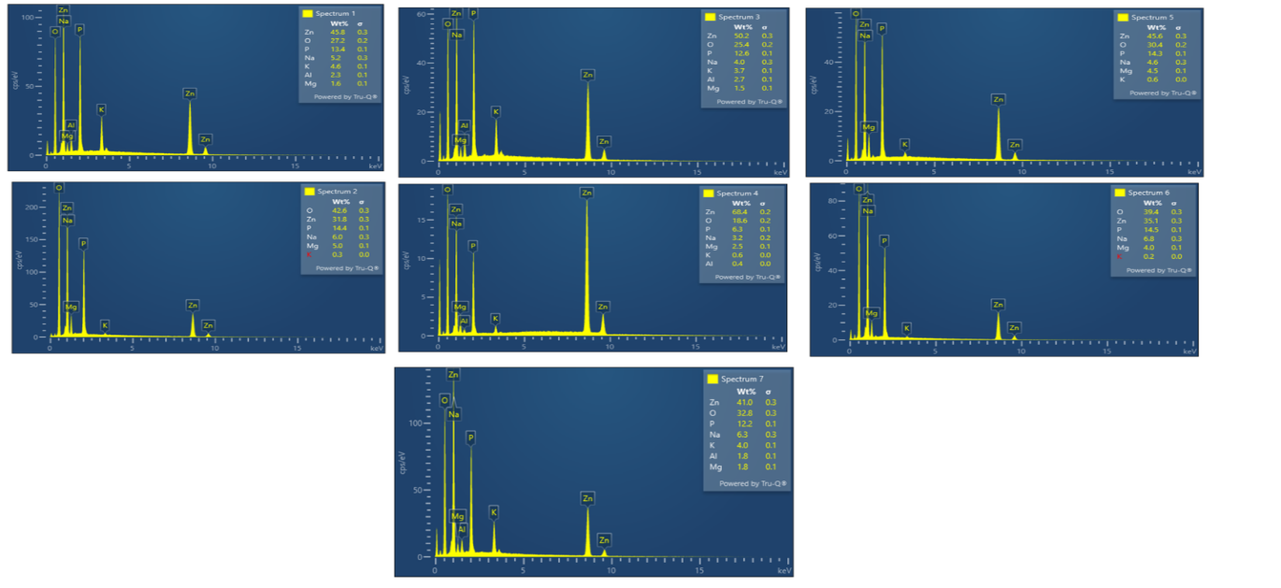
Figure 1: ICP analysis of Zn P in Saliva (spectrum 1 to spectrum7)
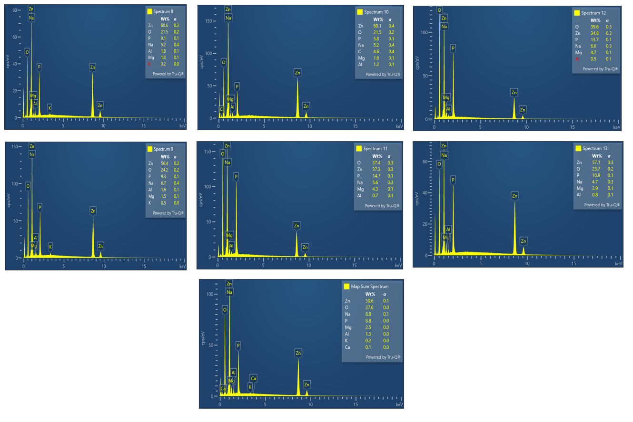
Figure 2: ICP analysis of Zn P in water (spectrum 8 to spectrum13; map sum spectrum)

4.2 Interpretation of the spectrum obtained for saliva:
The data from Figure 1 and Table 3 represents the elemental composition of samples obtained from saliva, as determined through spectral analysis. Each spectrum label corresponds to a different sample, and the values represent the percentage composition of various elements.
Spectrum 1: This sample has relatively higher percentages of zinc (Zn) at 45.80% and phosphorus (P) at 13.37%. Other notable elements include oxygen (O) at 27.25% and potassium (K) at 4.56%.
Spectrum 2: Oxygen (O) is the predominant element in this sample at 42.56%, followed by phosphorus (P) at 14.40% and potassium (K) at 31.78%.
Spectrum 3: The primary constituents are oxygen (O) at 25.36% and phosphorus (P) at 12.61%. Zinc (Zn) is also present at 3.66%.
Spectrum 4: Oxygen (O) is the dominant element at 18.55%, followed by phosphorus (P) at 6.34%. Zinc (Zn) is present at a lower concentration of 0.56%.
Spectrum 5: This sample contains oxygen (O) at 30.36%, phosphorus (P) at 14.33%, and zinc (Zn) at 0.60%. Other elements are also present in minor amounts.
Spectrum 6: Oxygen (O) is the primary element at 39.39%, followed by phosphorus (P) at 14.49% and potassium (K) at 35.06%.
Spectrum 7: Oxygen (O) constitutes 32.79%, and phosphorus (P) accounts for 12.18%. Potassium (K) and zinc (Zn) are also present in notable amounts.
Oxygen (O) and phosphorus (P) are consistently present in significant percentages across all spectra. Zinc (Zn) is detected in varying quantities, with some samples having higher concentrations than others. Potassium (K) is present in some samples but not consistently across all spectra.

4.2 Interpretation of the spectrum obtained for water:
The data from 4 and figure appears to represent the percentage of different elements in each sample, with the total sum being 100% for each spectrum.
Spectrum 8: This sample has a high percentage of zinc (Zn) at 60.57%, while oxygen (O) constitutes 21.55% and phosphorus (P) makes up 9.12% of the composition. The other elements, including sodium (Na), magnesium (Mg), aluminum (Al), and potassium (K), have lower percentages.
Spectrum 9: Similar to Spectrum 8, this sample also contains a relatively high amount of zinc (56.36%). Oxygen (O) and phosphorus (P) are the next significant elements at 24.16% and 9.26%, respectively.
Spectrum 10: Spectrum 10 shows a different elemental composition compared to the previous two samples. Oxygen (O) is the most abundant element at 21.48%, followed by phosphorus (P) at 5.79%. Zinc (Zn) is present at a lower concentration of 60.15%.
Spectrum 11: In this sample, oxygen (O) is the most dominant element at 37.41%, followed by phosphorus (P) at 14.67%. Zinc (Zn) is significantly lower at 37.29%.
Spectrum 12: Spectrum 12 has a similar composition to Spectrum 11, with oxygen (O) and phosphorus (P) being the most abundant elements at 39.62% and 13.75%, respectively. Zinc (Zn) is again lower at 34.82%.
Spectrum 13: This sample has a balanced composition, with oxygen (O) at 23.66%, phosphorus (P) at 10.92%, and zinc (Zn) at 57.06%.
The content of zinc (Zn) in the water samples varies across the different spectra, ranging from around 34% to 60%. Oxygen (O) and phosphorus (P) are consistently present in significant amounts across all spectra. The presence of other elements (sodium, magnesium, aluminum, potassium) is minimal compared to oxygen, phosphorus, and zinc.

4.3 Comparison of interpreted data of sample in water and saliva:
The comparison is based on the results obtained from the spectral analysis of samples in saliva and water (Table 4 and Table 3; Figure 2 and Figure 1). The relative percentages of the elements present in both saliva and water samples were focused. concentration of oxygen in saliva ranges from 18.55% to 42.56%, while in water, it ranges from 21.55% to 39.62%. The oxygen content appears to be relatively higher in the water samples compared to saliva.
The sodium content in saliva ranges from 3.19% to 6.82%, whereas in water, it ranges from 4.25% to 6.66%. The sodium levels are relatively similar between the two sets of spectra, with no significant differences observed. In saliva, the magnesium content ranges from 1.51% to 4.95%, while in water, it ranges from 1.43% to 5.17%. The magnesium levels show some overlap in the ranges, but no clear pattern emerges.
Aluminum is detected in saliva samples but not consistently present in the water samples. In saliva, the aluminum content ranges from 0.41% to 2.70%. The phosphorus content in saliva ranges from 6.34% to 14.40%, while in water, it ranges from 9.12% to 14.67%. The phosphorus levels appear to be slightly higher in water. The potassium content in saliva ranges from 0.22% to 4.56%, while in water, it ranges from 0.24% to 0.46%. The potassium levels are generally higher in saliva, and there is a significant difference between the two sets of spectra.
The zinc content in saliva ranges from 31.78% to 68.41%, while in water, it ranges from 34.82% to 60.57%. The zinc levels appear to be relatively higher in water. The elemental composition of saliva and water samples shows similarities and differences. Both saliva and water contain essential elements such as oxygen (O) and phosphorus (P). Some elements, like aluminum (Al) and potassium (K), are detected in higher concentrations in saliva than in water. The zinc (Zn) content appears to be higher in water samples, while the magnesium (Mg) levels show no clear trend.
Note: It's essential to consider that the concentration of elements in saliva and water can vary based on various factors, including the individual's diet, the source of water, and other environmental influences. Further investigations and comparisons with reference data or regulatory standards may be required for a comprehensive assessment of the samples' elemental composition.

4.4 SEM imaging:
Scanning Electron Microscopy (SEM) can play a significant role in the study, which involves analyzing the elemental composition of samples obtained from water and saliva. SEM can provide valuable visual and structural information that complements the elemental analysis. SEM imaging from figure 3 shows all spectrum obtained hen zinc phosphate disc placed in water. All elemental compositions like Sodium, Zinc, Oxygen, Phosphate, Magnesium and Aluminium can be seen in SEM at the particle size of 500um (Figure 4).
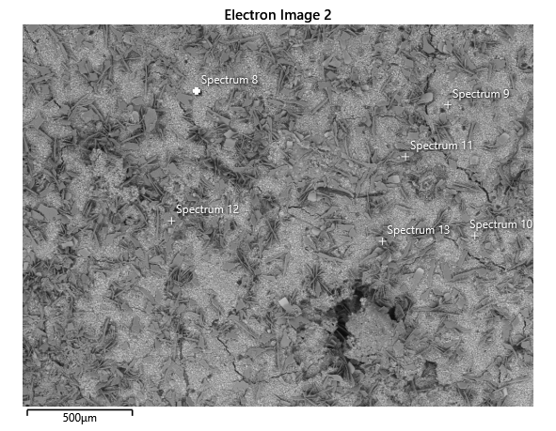
Figure 3: Particle size of 500um; all spectrums from Figure 2 can be observed (water)
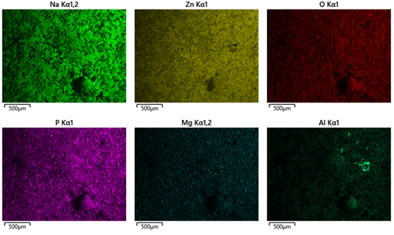
Figure 4: Various elemental composition with particle size 500um can be observed
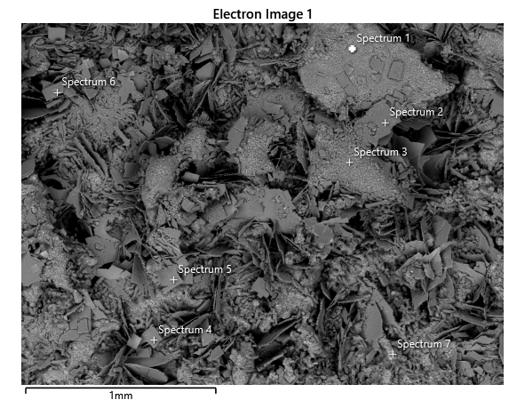
Figure 5: SEM of spectrums developed for sample in Saliva
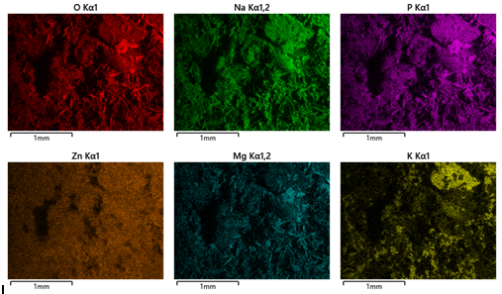
Figure 6: Various elemental compositions with particle size 500um can be observed
SEM imaging from Figure 5 shows all spectrum obtained hen zinc phosphate disc placed in water. All elemental compositions like Oxygen, sodium, Phosphate, Zinc, Magnesium, and Potassium can be seen in SEM at the particle size of 500um (Figure 6).
The SEM images (Figure 3 - Figure 6) shows the surface morphology of the samples in high detail; physical structure of the samples, such as the texture, roughness, and overall surface characteristics can be observed from these images. The spatial understanding of where different elements are concentrated is studied, which was interpreted in ICP analysis. SEM revealed microstructural details like pores, cracks, and other structural characteristics that could impact the behavior and properties of the samples.
- CONCLUSION:
The findings indicate that dental cement exhibits distinct behavior when exposed to different environments. The pH levels of the surrounding liquid were influenced by the cement's interaction, and ion release patterns varied over time. These results suggest that the cement's composition plays a significant role in its ion leaching behavior and its potential applications in various fields, including dentistry and biomaterials.
- LIMITATIONS OF RESEARCH:
- Extending the study beyond one month could reveal how dental cement behaves over extended periods, providing insights into its long-term stability and performance.
- Assessing the mechanical strength and durability of the cured cement could provide crucial information about its suitability for various applications, such as dental restorations.
- Conducting biocompatibility tests to assess the interaction of dental cement with living tissues could pave the way for its use in medical implants and dental procedures.
- Further research could explore the practical applications of ZnPO₄ cement in dentistry and other medical fields, potentially leading to the development of novel treatments and materials.
- REFERENCES:
- Ishikawa, K. M. (2003). Bioceramics. Comprehensive Structural Integrity. In Bio Ceramics (pp. 169 - 214). Japan: ACS Publicaions.
- B Haller, A. T. (1998). Effect of multi-step dentin bonding systems and resin-modified glass ionomer cement liner on marginal quality of dentin-bonded resin composite Class II restorations. Clinical Oral Investigations, 2 (3), 130 -136.
- Zana D. Lila-Krasniqi, R. B. (2022). Evaluation of Antimicrobial Effectiveness of Dental Cement Materials on Growth of Different Bacterial Strains. Med Sci Monit Basic Res , 28, e937893-1–e937893-6.
- C.H, P. (2012). Clinical and technical considerations of luting agents for fixed prosthodontics. Int. J. Dent., 565303.
- S.B, M. (2008). Dental cements: Formulations and handling techniques. In W. T. Curtis R.V., Dental Biomaterials: Imaging, Testing and Modelling (pp. 162-193). Duxford, UK: Woodhead Publishing.
- Kispélyi, D. B. (2017, 05). Dental Cements. Budapest, Hungary.
- Hamdy, T. M. (2018). Novel Bioactive Zinc Phosphate Dental Cementwith Low Irritation and Enhanced Microhardness. J. Surf. Sci. Nanotechnol., 431 - 435.
- Wilson A D, K. B. (1971). The glass-ionomer cement: a new translucent dental filling material. J Appl Chem Biotechnol, 313.

